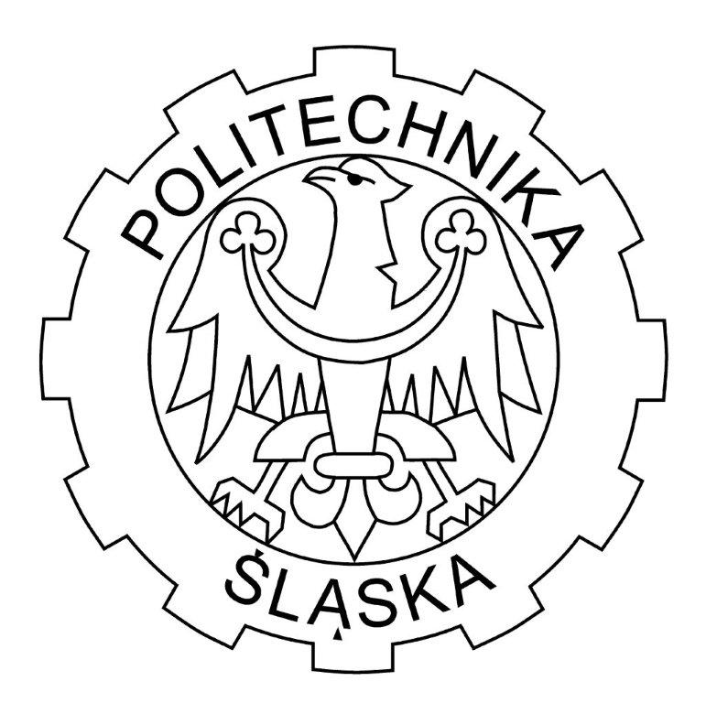

SOFTWARE ENGINEERING
Development Methodology
Project: DATA MINNING

Group:
Marzena Kula
Maciej Gombos
Mateusz Ośliślok
Jakub Dudys
Eduardo Martinez Rivera

History of changes
Date | Version | Changes / Comment
4.11.2013 | 1.0 | First version of our documentation.  Preliminary development methodology.
8.11.2013 | 1.1 | Update and expand our documentation.
18.11.2013 | 2.0 | Change of the technology and update the navigation links.

Project stages and development cycle

At the beginning we were considering two different concepts of making our project:
ASD – Agile Software Development and PDD – Plan Driven Development.
In the case of PDD one in the Plan driven model the team will deploy one increment of software at the end of the project. But in Agile we will deploy very small change of the software or more frequently. The second one is sequential verses concurrent activity. In Plan driven development one process starts after successful completion of another. But in Agile we plan all the time. ASD divides whole project into smaller sub-projects including all steps of software developing as: analysis, development, testing, integration and validation.
We know that these times 60-80% of software developers use the first one, ASD.
Following graphs pictures the difference between those two concepts:
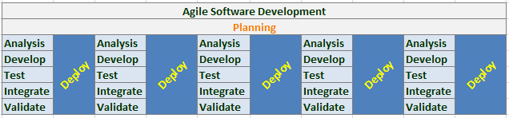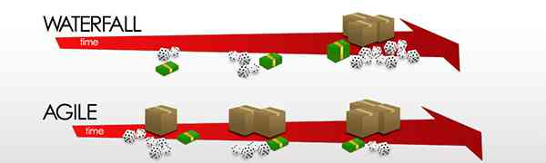

After analyzing the pros and cons we chose Agile Software Development.

Project Roles

Maciej Gombos – programmer, responsible for Graphical User Interface
Mateusz Ośliślok – programmer, responsible for algorithm development
Jakub Dudys - programmer, responsible for algorithm development
Eduardo Martinez Rivera – programmer and tester
Marzena Kula – tester, graphic designer, responsible for documentation

Repository for project and documents

GitHub web-based hosting service for software development projects that use the Git revision control system. GitHub offers both paid plans for private repositories and free accounts for open source projects.
We can also use TortoiseSVN for downloading data. TortoiseSVN is free software for software developers. It helps programmers manage different versions of the source code for their programs.
https://github.com/skorek/datamining

Bug tracking system

YouTrack is commercial browser-based bug tracker, issue tracking system and project management software. Free for 10 users; access through www domain access.
http://dataminning.myjetbrains.com/youtrack/dashboard

Testing plan and procedure

Unit testing - individual units of source code, sets of one or more computer program modules together with associated control data, usage procedures, and operating procedures are tested to determine if they are fit for use.
We believe that for our development method ASD, this kind of testing procedure will fit perfectly, because we are going to develop our application step by step, small unit tests are the best way to check usability of small code parts.

Technology

We chose Microsoft Visual Studio Express 2012, because is a set of freeware integrated development environments (IDE).
We chose the following programming language:
C# - tons of libraries, Windows Forms, easy file enforcement

